**LAB 9**

Questions:

Task#1

Write ASM instructions that calculate EAX * 21 using binary multiplication.

Hint: 21 = 2^4+2^ + 2^0

Task#2

Give an assembly language program to move -128 in ax and expand eax. Using shift and rotate

instruction.

Task#3

Write a series of instructions that shift the lowest bit of AX into the highest bit of BX without using

the SHRD instruction. Next, perform the same operation using SHRD.

Task#4

Implement the following C++ expression in assembly language, using 32-bit signed operands:

val1 = (val2 / val3) * (val1 / val2);

Task#5

Create a procedure Extended_Add procedure to add two 64-bit (8-byte) integers.

Q1

Code:

INCLUDE Irvine32.inc

.data

var DWORD 7 ; value to store in eax

.code

main PROC

mov eax , 0

mov eax , var

; eax * 21

shl eax , 4 ; eax = eax * 2^4

mov ebx , eax

mov eax , var

shl eax , 2 ; eax = eax * 2^2

mov ecx , eax

mov eax , var

shl eax , 0

add eax , ecx

add eax , ebx

call Writeint

call Dumpregs

exit

main ENDP

END main

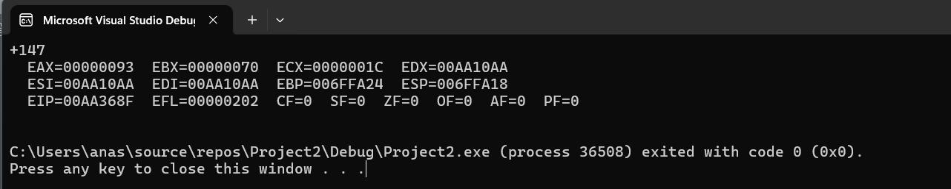

Q2

Code:

INCLUDE Irvine32.inc

.data

.code

main PROC

mov ax , -128 ; high half of eax is filled with zeros

shl eax , 16 ; shift the FF80h(-128) 16 bits to the left filling 16bits rights filled with zero

sar eax , 16 ; performs airthmetic shift to the right while conserving sign(ffffff80h)

call Writeint

call Dumpregs

exit

main ENDP

END main

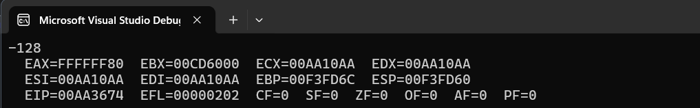

Q3

Code:

INCLUDE Irvine32.inc

.data

.code

main PROC

mov ax , 12

and ax , 1 ; isolating lowest bit

shl ax , 15 ; loswest bit move to highest bit of ax

mov bx , 0

or bx , ax ; bx highest bit is set according to ax's lowest bit

call Dumpregs

exit

main ENDP

END main

USING SHRD INSTRUCTION

shrd ax , bx , 1

Q4

Code:

INCLUDE Irvine32.inc

.data

val1 DWORD 2 ; can be changed later

val2 DWORD 2 ; can be changed later

val3 DWORD 2 ; can be changed later

.code

main PROC

mov eax , 0

mov eax , val2

cdq ; Sign-extend EAX into EDX for division to preserve sign

mov ebx , val3

idiv ebx ; eax = val2/val3

mov ecx , eax ; to store result of val2/val3 in ecx

mov eax , 0

mov ebx , 0

mov eax , val1

cdq

mov ebx , val2

idiv ebx ; eax = val1/val2

imul ecx ; eax = (val2/val3) * (val1/val2)

mov val1 , eax

call Dumpregs

exit

main ENDP

END main

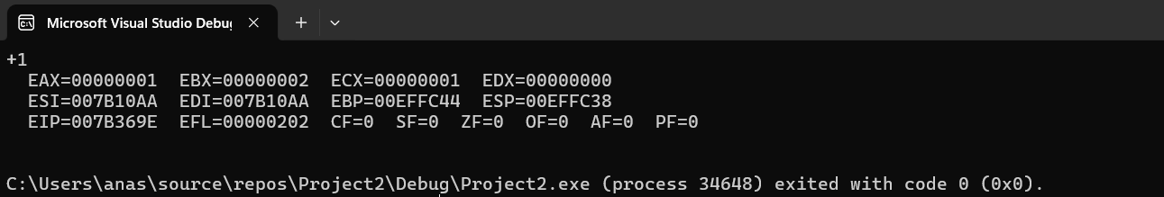

Q5

Code:

INCLUDE Irvine32.inc

.data

low1 DWORD ? ; Lower 32 bits of the first integer

high1 DWORD ? ; Upper 32 bits of the first integer

low2 DWORD ? ; Lower 32 bits of the second interger

high2 DWORD ? ; Upper 32 bits of the second integer

.code

main PROC

mov eax , 0

call Extended_Add

main ENDP

exit

Extended_Add PROC

mov eax , low1

mov ebx , low2

add eax , ebx

;now add the carry(if any) from the lower bits of integer to higher bits

mov eax , high1

mov ebx , high2

adc eax , ebx ; eax = high1 + high2 + carry

call Writeint

ret

Extended_Add ENDP

call Dumpregs

exit

main ENDP

END main

Assigned some values to low1,high1,low2,high2 for output

